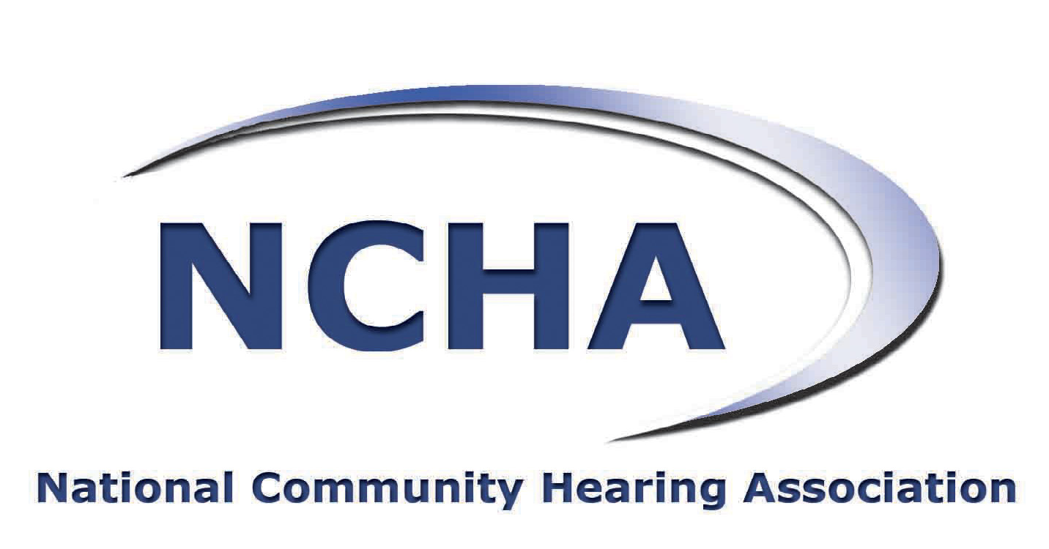 | 

As the representatives of community hearing providers in England, we welcome this opportunity to comment on ‘The 2014/15 National Tariff Payment System’ consultation.

The National Community Hearing Association (NCHA) represents community hearing providers in the UK. NCHA members are committed to good hearing for all and are responsible for the majority of adult community hearing care services in the UK with an excellent record of outcome, safety, and patient satisfaction.

BSHAA is the professional body for hearing aid audiologists providing hearing care to NHS and self-funding clients. They practise in large, medium and small companies and as sole practitioners; and they provide a professional, convenient and local service to people with hearing concerns in every community in the UK.

The NCHA and BSHAA fully support Monitor’s efforts to bring more science and transparency into traditional NHS costing and pricing systems. As a sector we see ourselves very much as part of the four opportunity categorisations set out in Closing the NHS funding gap: how to get better value health care for patients (Monitor 2013):

- improving productivity within existing services – we and AQP more generally are very much at the heart of QIPP
- delivering the right care in the right setting – better outcomes, lower costs, more appropriate settings; increased care in the community for people with long-term conditions improving their experience and reducing hospital visits
- developing new ways of delivering care – bringing private sector skills, cost control and supply chain efficiencies to the NHS exploiting existing infrastructures
- allocating spending more rationally – redirecting resources to prevention and early diagnosis to achieve better outcomes and longer-term economies.

Our Interest

The NCHA and BSHAA appreciate the extension in the deadline for this consultation as this has allowed us to comment. Although we do not operate under the mandatory tariff system and therefore were not on the standard consultation list, we do have a major interest in this consultation as community hearing providers and particularly in the way non-mandatory tariffs are explained to and interpreted by commissioners across England.

We fully understand the weaknesses in the underpinning methodology and the effort Monitor is making to get this right. We also fully support the need to move towards more realistic tariffs for mandatory pricing in order to squeeze out inefficiencies from the acute sector, have more transparent public sector costing and pricing and to achieve better use of overall NHS resources. All that we take as given.

Our Concerns

Where we have concerns however is that NHS commissioners will not have the time to read and understand this very technical document. In addition by including the non-mandatory tariffs in an Excel document titled “National Tariff Information Workbook” we are concerned that the difference between “rules” and “guidance”, which we understand and support, will not be understood by average commissioning staff who will not have the time to study the large body of text in the separate document or to understand what is a complex consultation.

The risk is that many commissioners will simply read the non-mandatory tariffs as an instruction to cut prices further for contracts that have only recently been agreed or to seek unrealistic prices for new contracts which will be unachievable without jeopardising quality and patient care.

As Monitor will know, there is a significant body of research which demonstrates that competition based on quality (rather than price) is in patients’ best interests and we would urge Monitor to make this position in the non-mandatory ‘guidance’ much clearer. This would be to avoid introducing systemic risk to all community based services.

As it stands commissioners might well now ignore or be ignorant of previous Department of Health guidelines (on which this guidance builds) that local prices should be negotiated locally. They are also likely to misunderstand “non-mandatory” tariffs as prices derived from robust costing methods for community services – which of course they are not. We would strongly advise that these points be clarified in order to prevent unnecessary problems and barriers to the next round of community services commissioning.

Community adult hearing services in particular are commissioned locally through the AQP tender process and providers invest private capital to ensure that a high-quality, patent focussed service can be provided backed up by quality and outcomes data which can be collected and disseminated. These reporting requirements have already resulted in extremely tight margins on the provision of adult hearing services and consequently many smaller providers are already being prevented from entering the market, contrary to the government’s intention.

Further, and arbitrary, reductions in non-mandatory tariff for adult hearing services as potentially mis-signalled in supplementary documents the current draft guidance (“The national tariff information workbook [Excel]. This workbook provides operational information for implementing the 2014/15 national tariff”) will not only choke off competition but would also go strongly against the evidence - econometric studies and other research – that crude price reductions can only result in reductions in quality. This would also be counter to the government’s reassurances that the 2012 Act would result in competition on quality rather than price alone.

No evidence is presented in the draft guidance – nor are we aware of any - that would justify a reduction in the non-mandatory tariff for adult hearing services. We would therefore argue on economic and market grounds against arbitrary efficiency gains across all services and instead that any such gains be targeted at specific areas which are known to be inefficient.

Furthermore, Monitor is aware that costing methodologies in secondary care –as highlighted by a report prepared for it by PwC - require significant improvement. The community providers of adult hearing services cannot and should not cross-subsidise services through inefficient cost-allocation. It is not right that users of the NHS should have less access to care in the community simply as a result of historically poor costing methodologies in secondary care.

Current Pressures

The current commissioning system - which involves expensive data extraction for different and constantly changing data sets required by each CCG - is already adding significantly to costs in the community rather than enabling providers to operate more efficiently – to which end we would very much welcome a national data set and national pathway. We therefore urge Monitor to send a signal to commissioners to engage with providers when requesting data to ensure their requests are evidence-based rather than sending a signal that adult hearing services are now cheaper to provide despite the ever-increasing costs introduced by commissioners into the provision of these services. This current approach is unsustainable and therefore unfair on users of NHS services.

In addition in 2013, many providers are still wrestling with the issue of VAT which should - under [National Contract 2013/14 Service Conditions p.39] - have been excluded from the tariff price but which providers have now been told unilaterally they may have to fund themselves. This additional provider cost is not reflected in the ‘non-mandatory tariff’ and risks increasing the already un-level playing field between community and hospital providers.

The reimbursement advice/guidance should be methodologically sound and until it is improved either these weaknesses should be made more explicit to all or the non-mandatory tariff for adult hearing services should be removed.

Another complication is that the majority of adult hearing contracts have been in existence for barely more than a few months and this unclear approach to setting and communicating the non-mandatory tariff creates uncertainty and confusion for providers and commissioners and could be disastrous for the next stage of the community service development which the government wishes to see.

Improvements to Guidance

Whilst Monitor has attempted to draw a distinction between ‘guidance’ and ‘rules’, we fear that this will be lost on most commissioners who prefer simplicity, and would urge Monitor to be more explicit and send a clearer market signal about all services – and particularly adult hearing services - that have a non-mandatory tariff. At this stage in their evolution commissioners need very clear guidance about how to use non-mandatory tariffs.

In particular we would support

a) Monitor reiterating the previous Department of Health principles that local prices should be negotiated locally

b) non-mandatory tariffs for all services being explicitly listed in an Excel sheet titled “non-mandatory price (guidance only)” and for the first page to reiterate guidelines to commissioners and to explain that these are different from mandatory tariffs (rules).

This, we believe, would be a clearer and more transparent way of framing this information for commissioners and should prevent the negative impact on service delivery and development we anticipate will otherwise result and which would have the detrimental effect of halting the government’s plans to transfer care out of hospital into more cost effective community settings; removing focus from quality to a price.

The tariff system should drive cost-effective, sustainable and quality services in the NHS; it should not be used to drive down price without regard to these dimensions of service. The current draft risks creating an NHS where the most vulnerable – e.g. the elderly with sensory loss – are put at risk due to poor communication and understanding.

The key for us is that local prices should be agreed locally to reflect the quality and volume of the services the commissioners want to see in place. We therefore ask Monitor to make it clearer in this guidance or in a covering summary for commissioners that the non-mandatory tariffs are ONLY “guidance” and are a by-product of the work that is going on in the hospital service and are not to be taken as indicative prices – especially not for locally commissioned services in the community.

We will of course issue guidance to the adult community hearing sector to this effect but it would be very helpful if this were reiterated in Monitor guidance to avoid confusion for commissioners and providers and to ensure we can continue to play our full role in delivering the government’s plans of reducing pressure on the hospital sector and increasing patient choice whilst continuing to drive up efficiencies across the NHS.

We would be more than happy to work with Monitor to clarify this guidance and also to share our guidance with Monitor so that we can ensure both commissioners and providers receive the same consistent messages and improve market symmetry and efficiency.

We hope these comments are helpful and acceptable and will lead to a more effective final version of the guidance.

We would also ask to be included on Monitor’s stakeholder lists for both on mandatory and non-mandatory tariff communication and consultations.

